Mt. Holly & Pine Knob

2011-2012 Instructor's Manual – www.instructorssite.com

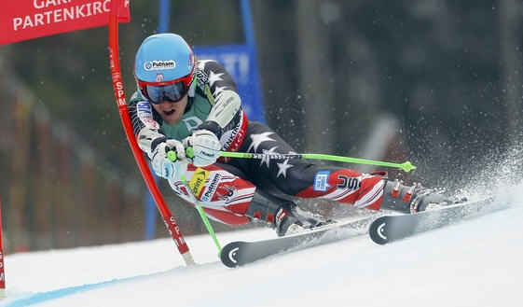
Ted Ligety skis to victory in the giant slalom at the world championships in Garmisch-Partenkirchen, Germany.

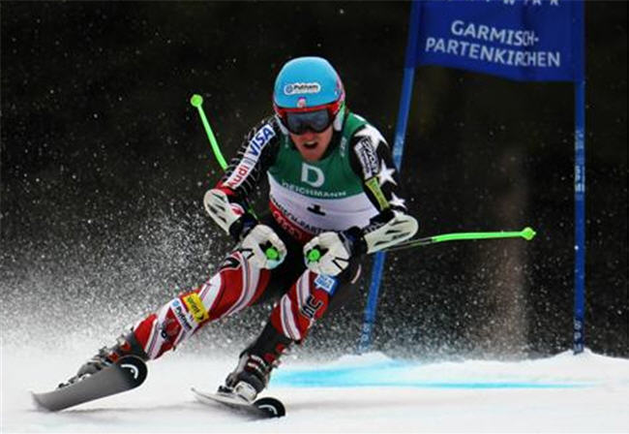

Nice early weight transfer for the new right turn! Ligety won the 2011 World Cup GS Title!

Ted gets a lot of coaching because skiing well is a constant challenge. Good instruction provides clear goals and precise feedback.
Mt. Holly and Pine Knob

Instructor's Manual 2012 Edition ©

Mt. Holly Director- Pam Deibel
Pine Knob Director- Pat Deibel
Technical Director- Mike Seiler
Mt. Holly Ski School- 248 634-3249
Pine Knob Ski School- 248 625-0800
Deibel Residence - 248 674-0811
Email- MHPKSS@att.net

Contents

Introduction 3

Goals 4

What to teach 5

How to teach 6

Student lessons 8

Kindersparks 16

Private lessons 17

Exercises 18

Racing 21

Skiing Principles 23

PSIA 25

Your Responsibility Code 26

Online resources 27

Web site - www.instructorssite.com

INTRODUCTION

Most people teach part time as a way to improve their skills and interact with others who share their passion. It is also a way to earn some extra money and make the sport more affordable. But it is very important that you enjoy helping people learn.

Season

The season usually starts on Thanksgiving and runs through early March. Periods of rainy weather or extreme cold can interrupt the season. Christmas through the second week of February is the busiest time. If you take a winter vacation, plan it as late as possible. March is when conditions at the larger resorts are the best. Early December is an important time to clinic.

Programs

Student lessons are given to groups of school children on weekday evenings. Kindersparks are provided for children on weekends. Adult league racing and Thunderbolt racing are offered evenings and weekends. Private lessons are available at the customer’s request.

Schedule

Each season you must submit a schedule. Four days are requested, but a minimum of three days per week must be worked. Weekday evenings from 5 pm - 7 pm and weekend mornings starting at 9 am are the busiest times when you're needed the most. Any extra days you can work are helpful, especially during holidays

Requirements

- Instructors are independent contractors, so you are responsible for buying your own equipment and ski school Jacket. You do not receive health insurance, workers compensation, or unemployment. Instructors must purchase liability insurance from the ski school. New instructors go through a trial period when they are evaluated on their work habits, involvement, attitude, and ability. Instructor status is usually achieved after several weeks of acceptable performance.

- Instructing is more casual and fun than other work, but you must remember that it is a real job and treat it as such. Teaching requires hard work and commitment of time. Be on time to work and call when you can't come in. Maintain a professional appearance and keep your uniform clean. Be polite, courteous, and helpful to all the customers and employees at the resort.

- All instructors, new and returning, should re-evaluate the reason they want to be instructors. If you don't love teaching, or if other priorities prevent you from meeting ski school requirements, you should reconsider your participation.

Policies

- You are responsible for your lesson tickets and will be paid only for what you turn in. Submit them on Monday, and receive a check on Thursday.
- Sign in and out every time you are at the resort. Any time you are at the resort, we may ask you to work if a need arises.
- No guests are permitted in the instructor's room. You are allowed to keep only one set of equipment (snowboard and skis) in the instructor's room. Remove your equipment before the end of the season. It will not be safe during the summer.
- Instructors are not allowed behind the ski school desk unless asked to help out.
- You are not permitted in the bar before 9 pm.
- The ski school uniform must be worn: jacket with ski school pass
- Always listen for pages and frequently check if instructors are needed, especially when the resort is busy.

Training

You can always improve your teaching and skiing. As you improve, instructing becomes more fun and rewarding. Students who were frustrating become an interesting challenge and achieve greater success. Private lesson customers may return to take more lessons so you earn more money!

Review this manual and watch the online student lesson videos at www.instructorssite.com

Instructors are required to attend the first two student lesson review clinics each season. These will be about 60-90 minutes long each. Optional review clinics will also be given for the other student lesson clinics. Instructors are encouraged to attend the ones you are interested in teaching. Most of the clinics will be offered in December.

Instructor Evaluation

Instructors are randomly evaluated throughout the season so we can identify teaching areas that need improving. Emails are sent to the entire staff with recommendations for improvement Instructors will also be evaluated in the student lesson review clinics.

Goals

Skiing provides excitement, freedom, and creativity. Most people create their own way to ski by applying natural movements they make every day. Few skiers take lessons let alone receive daily coaching like the top racers. But skiing well is not intuitive; it requires movements that can be opposite our natural movements. Skiing frequently is not enough to produce improvement.

As a result, most people ski on the back of their skis with rotation and no angulation. But many don’t realize what could be improved, they think they know how to ski and don’t consider lessons. Some get bored long before they can ski well.

Only a few basics are needed to ski well, but it takes years of practice and constant refinement to execute them well. Each change in terrain, conditions, and speed will challenge these skiing movements.

Our bodies often provide inaccurate feedback about how we are moving, so it can be very hard to know how we are moving. Years of skiing with unwanted moves reinforces these moves and creates habits that are hard to change.

Few people understand how challenging it is to ski well. If they take a lesson it is often to reach a simple goal like being able to ski with their friends and family. They usually are not looking to become real involved in the sport. Getting most people to flex their ankles and keep their upper body moving forward is very hard, so unless they are really committed to skiing well, it is usually most productive to work on creating some inside lead and angulation.

Sometimes providing a greater understanding creates more dedicated skiers, but clear goals and precise feedback are the keys to reaching any goals.

What to Teach

The two key moves are progressively flexing the ankle and tipping the upper body to the outside of the turn (flex and tip,) numbers 4 and 5 below. These moves keep the body moving forward and toward the next turn. The first three basics provide the foundation for flexing and tipping:

1) Skiing stance- flex ankles, knees, waist, and back over the center of the ski; hands in front

2) Weight transfer - to the new outside ski

3) Inside lead- progressively advance the new inside ski tip, hip, shoulder, and hand *

4) Flex ankle- progressively pressures the ski tip and keeps forward motion*

5) Tip (angulation) - progressively tip the upper body to the outside of the turn*

* Timing is critical, these 3 moves must be progressive

To remember the basics think S.W.I.F.T

Here is a picture of the basics- the skier is in a good skiing stance with most of his weight on the outside (left) ski-

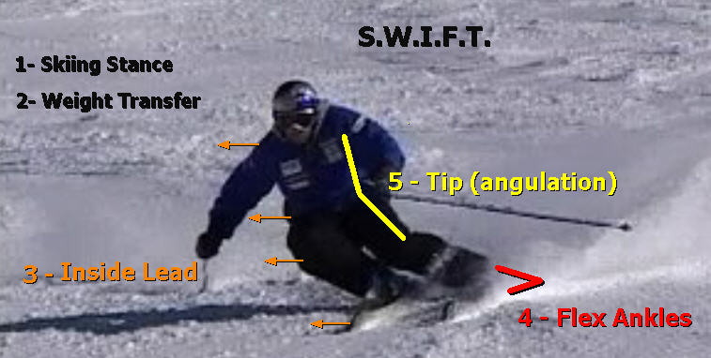

A turn can end at the apex or later. When the edges are releases the body starts moving in a straight path over the skis which keep turning until the crossover point for the next turn.

There are two ways to turn: the skis can turn you or you can turn the skis with rotary movements. Turns can be a combination of these two. Skiers usually start in a wedge and progress to parallel skiing. They work on these five basics to develop a feel for how the ski makes a turn, and will also learn to turn their feet to steer the skis.

How to Teach

Knowing what to do is different than knowing how to do it. An instructor needs to know how to evaluate a skier, and help them develop with the right exercises. It requires time and experience to teach well.

Two Basics-

1) Demonstrate and explain - Focus on one movement. Demonstrate statically while giving a brief explanation.

2) Provide feedback - Have the students perform statically and provide feedback as they perform. If the student can not make the move, physically help them. When they ski, give feedback as they perform or immediately after they finish. Make specific comments such as: more ankle flex, less knee flex, or good when they do it right! Feedback is a critical part of teaching; it requires a lot of concentration.

Evaluate (Movement Analysis)

- One way to evaluate skiers is to look for the three natural movements that make skiing a challenge at every level of development. Each time the hill gets steeper, speed increases, or conditions are more difficult watch for these moves.

1) Leaning back- this usually at the ankles, knees, waist, and/or back

2) Rotation- turning the upper body in the direction of the turn, as when walking

3) Leaning in- the upper body moves inside the turn, as in a turning car

One move can cause another, look for the cause not just the visible effect. Moving back takes pressure off the front of the ski which makes it hard to turn, so skiers tend to rotate even more. When a skier rotates it makes it hard to tip the upper body to the outside of the turn (angulation,) so skiers will lean more inside the turn. These natural moves make the body go back, down, or inside the turn, rather than moving forward and downhill.

Because problems with stance and ankle flex cause other problems it is important to develop these basics right from the start with new skiers. But it can be very hard to develop a good stance and ankle flex, especially in experienced skiers who have reinforced habits. Even new skiers will usually lean back after the lesson as they ski faster or go to a steeper hill. Time is limited so it may be most productive to work on fixing the rotation and creating angulation first.

- Another method, especially for more advanced skiers, is to look for basics from the start of a turn. This is at the transition point from one turn to the next when the skis are flat, and is called the crossover point. It can be harder to see how more advanced skiers are moving, so it is helpful to have the student ski past you to get the front, side, and rear view. Look at the skier’s body; is it moving offensively (flex and tip) or is it moving defensively: back, inside, and down.

Problems with knee flex are very common but can hard to see. They can be flexed be too soon, too quick and last too long relative to the ankle flex. As a result the body moves back and down rather than forward and downhill.

Also check for symmetry problems, right handed skiers tend to turn better to the left, and left handed tend to turn better to the right.

Here are some pictures-

Intermediate skier
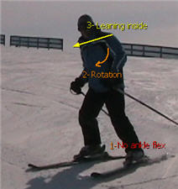

Advanced skier

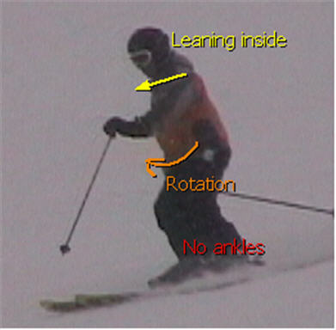

Expert skier making a bad turn

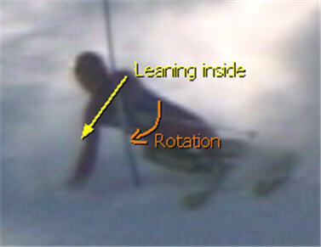

Student Lessons

Student lessons are taught to school groups weekday evening from 5 pm - 7 pm. Pine Knob has student lessons on Sunday evenings at 4 pm. Students receive a special lift ticket which restricts where students can go until they pass the required lesson. Keep the students safe! If any students are a discipline problem, correct the behavior. Never swear or act unprofessional in front of students.

The Students

Students must be at least 7 years old to be in the program. Many of these children have very little time skiing, so it will be hard to develop a high level of proficiency. Don’t expect perfection, they should have fun and develop some control. Always teach turning the feet to students who have trouble using the ski.

Time management

Finish on time, some parents leave immediately after the class. It could be ten or fifteen minutes after the hour by the time you have a class assignment. Figuring the time it takes to move the class, wait in lift lines, and do the grading, you might have less than thirty minutes to work with a large class.

General Points

Students need a lot of feedback especially in the first couple of student lessons. This is not the time for follow the leader. Save that for Kindersparks or private lessons.

- Be sure to have grading cards, don't lose these cards.
- Introduce yourself, and speak loudly enough for all to hear.
- Collect lesson tickets. Put in a secure place. You are not paid for lost tickets.
- Know how many are in your class and periodically check to make sure they are all with you.
- Be encouraging at grading time, especially with children who are about to cry.
- In case of an accident; shelter the injured student, send for help, don't move the student, look for any witnesses, talk about the details only with ski patrol and the ski school director

1- No Patch - stance, flex ankle to stop and turn

Check boots, gloves, hats, clothes. Know how many skiers you have, and make sure they follow you. Poles can help them walk, use one ski if necessary. Safety is critical, find the least crowded place, and keep them out of the path of other skiers.

1 - Stance -Compare standing tall to a skiing stance (flex ankles, knees, waist, and back; feet apart, hands in front, looking downhill.)

2- Ankle flex – In a skiing stance flex forward with the ankles; then return to the centered position, not bending the waist.

- Stand in a wedge; flex one ankle the knee moves in slightly. Provide feedback and help them move if necessary. Then try the other side.

-Side step and make a straight run.

2 - Stopping - From a straight run push the tails of the skis apart evenly. Try pointing the big toes at each other. Use the wonder carpet. Make three wedges in a row, then two, then one. The wider they make the wedge, the greater the stopping power. Some speed makes it easier.

Problems: leaning back at the ankles or waist, driving the knees together, crossing tips.

After the wonder carpet, show them how to use the rope to go a short way up the hill

3 - Turns - 4 parts: static practice, speed, flexing the ankle, and not turning too far

1- Stand in a small wedge, flex one ankle, then stand evenly on both skis; next flex the other ankle. Show which ankle to flex first, and help them if necessary.

2- Start skiing straight down hill in a wedge with some speed

3- Flex one ankle

4- Make a slight turn and then stand evenly on both skis to go straight before flexing the other ankle. The pattern is straight------flex ankle 1-----straight----- flex ankle 2.

Tell students how far they should go uphill, and that they must be in control to avoid the skiers
who are below them.

(Right from the first turn students develop a feel for how the ski works to make turns. When one ankle is flexed the ski responds by turning, and the student makes the connection between flexing their ankle and turning. They also feel their body automatically move downhill when they stop flexing the ankle which releases the edge of the ski. Student turn only as much as necessary, otherwise they learn to move with gravity, the same moves as advanced skiing.

This approach teaches offensive movements and how to use the skis so they make the turns. The alternative is to teach turning the legs to turn the skis. This is best done skiing straight downhill, if the student can do it, rather than traversing, turning and then traversing again.)

2-Yellow Patch- stance, flex ankle, tip, for turns on a steeper slope

1 - Review – stance, ankle flex, and stopping. Students may only have skied one time and it was a week or more ago, so review stopping before going very far up the hill. Then review turns, start by skiing straight down the hill with some speed. Pattern- straight---ankle flex turn---straight---

2 – Turns - Flex & tip - 4 parts

1- Static practice - Stand in a wedge facing the same direction as the students. Show them which ankle to flex first. Make sure they do it, help them if necessary. Next stand with equal weight on both skis, then flex the other ankle. (The knee moves in slightly as the ankle is flexed. Be sure it does not move out, or edge too much. Flex the right ankle for a left turn, and flex the left ankle for a right turn.) Then flex the ankle and tip that shoulder down toward the ankle (angulation)

2- Speed - Start by going straight downhill in a wedge with some speed

3- Flex the ankle and tip to turn--- go straight---- then flex the other ankle and tip

4- Don’t turn too far

3- Exercises - Students will naturally lean back, inside, and rotate rather than flexing their ankles and letting the ski make a turn. Build the connection between flexing the ankle and turning-

- Flexing ankle exercise- Make very quick ankle flexing moves to make small turns.

- Tipping exercise- Flex ankle and slide the hand from the hip to the knee.

- Go to a steeper slope, flex and tip longer for a more completed turn, but don’t turn too far and loose all the speed. Take the ones who are ready to the chair, give the rest exercises.

Watch for students edging too soon or too much, it can result in no turn or excessive speed. Statically practice edging the ski gradually.

Steering option- If you have students who can't use the ski, have them try turning both feet to turn the skis. Statically practice turning one ski at a time to feel the steering movement.

Grading - Tell students where they can ski with a yellow patch, and that they must ski in control to avoid the skiers below them. Tell them you want to see:

1) Skiing stance
2) Flex ankle and tip
3) Turn far enough to control speed

Have students ski down one at a time. If they don’t earn their patch, tell them why and what they should practice. Give successful students a yellow card and tell them to buy the patch at the ski school.

Yellow patch hills - Mt. Holly- Up to and including Grant's Trail.
Pine Knob- Up to, and including the Beginner chair

3- Brown Patch- stance, flex ankle, tip, more speed for matching

1- Review - stance, ankle flex, and turns. It may have been several weeks or last season since a student has skied, so start on the rope tow. Much of this lesson is reviewing yellow patch basics.

2- Matching - is the skis moving from a wedge to parallel position. This happens in the second half of the turn (wedge christie-1.)

- Statically practice flexing the ankle and tipping, then turning or steering the uphill ski parallel, try pushing down on the little toe of the uphill ski if it has too much edge

- Speed - ski straight downhill in a small wedge with some speed, the pattern is: flex-tip-match. With a small wedge, some speed, the right moves matching can happen naturally.

Be sure they don’t turn so far that they slow way down. If a student matches earlier or skis parallel, don't make them match later. Remember the steering option (turning both feet) for students who don’t use the ski properly.

3 - Exercises - problems are leaning back, rotating, and leaning in. Or the wedge is too big

- Traverse- start in a small wedge and repeat: flex, tip, and match (watch for traffic)

- Fan - match from a shallow traverse, then a steeper traverse, next head straight downhill

Grading - Tell students where they can ski with a brown patch, and that they must ski in control to avoid the skiers below them. Tell them you want to see:

1) Skiing stance
2) Flex ankle, tip, and match
3) Turn far enough to control speed

Tell students what they should practice.

Brown Patch Hills-
Mt. Holly- Up to and including Woodward
Pine Knob- Rope tows, chairs 1, 2, 5, 6 slopes- Quicksilver and Cedar Bowl

4- Blue Patch- stance, weight transfer, flex ankle, tip, and match in first half

1- Review - stance, flex/tip/match turns. Much of this lesson can be working brown basics.

2 - Weight transfer - to the new outside or uphill ski at the start of the turn. Matching happens before the fall line (when skis point downhill, wedge christie-2)

- Statically- On a gentle slope stand in a narrow wedge with skis pointing slightly downhill, and plant both poles downhill for support. Transfer all the weight to the uphill ski and match the skis. Upper body moves downhill toward poles. (We are now starting the top half of the turn first)

- Link turns- On a flat slope, use a steep traverse and a narrow wedge. Transfer weight and match the skis just as in the static exercise. In the second part of the turn, flex the ankles and tip. The pattern is - step, match, then flex and tip

3 - Exercises –

- One turn - Do one turn to a stop. Start with a steep traverse then use a one that is flatter. Practice in each direction if necessary.

- Second half of turn (christie) - In a shallow traverse with the skis parallel flex the ankles and tip.

- Then use a steeper traverse (fan exercise)

Introduce pole use - Have students bend their elbows and hold their hands in front of them. Swing the poles using their wrists. Then each time the pole swings forward touch it to the snow. Use the right pole before a right turn and the left pole before a left turn. The proper sequence is touch, match, and turn. If there is time they can try making turns with a pole touch.

Grading- Tell students where they can ski with a blue patch, and that they must ski in control to avoid the skiers below them. Tell them you want to see:

1) Skiing stance
2) Weight transfer, flex ankles, tip (match in first half of turn, poles use not necessary)
3) Turn far enough to control speed

Blue patch hills-
Mt. Holly- All but Lightning and Thunderbolt
Pine Knob- Rope tows, chairs 1, 5, 6, same as brown patch

5- Red Patch--stance, weight transfer, inside lead, flex ankle, tip (Parallel turn)

Students will be making parallel turns with pole touches, so students who don't have poles can take the class but they can't earn a red patch.

1- Review - Stance, weight transfer (matching before fall line,) flex, tip. Watch for leaning back, banking, and rotating.

2- Parallel Turns -

- Statically- On a gentle slope plant both poles below the downhill ski, stand with skis parallel across the hill and weight on the downhill ski. Transfer weight to the uphill ski and project downhill using the poles for support.

- Link turns- On a gentle slope use a steep traverse and make less completed turns. The pattern is transfer, flex ankle, and tip. Keep momentum flowing down the hill. Students regress on a steeper hill by leaning back, rotating, leaning inside, or reverting to a wedge, so develop confidence by first skiing faster on a flatter slope

- Pole touch- Statically review swinging and touching the downhill pole as the weight is transferred. Add to the turns, the sequence is swing, touch, and flex ankles.

- Inside lead- statically practice advancing the inside half. Then in a gentle traverse advance the inside half and come to a stop (uphill christie.) Then use a steeper traverse.

3 - Exercises –

- Inside lead- uphill christie with horizontal poles

- Uphill christie - on a steeper slope, students will lean back, rotate, and lean in. Work on the second half of the turn first to establish a sense of control. Working on any missing basic; stance, ankle flex, angulation, or lead. Also watch for excessive knee flex to force the ski to edge.

- One turn- On a steep slope do one full turn to a stop to build confidence and maintain good basics. Focus on a good start and finish. Then link turns.

Grading- Tell students where they can ski with a red patch, and that they must ski in control to avoid the skiers below them. Test on the steepest terrain they will be able to ski. Tell them you want to see:

1) Skiing stance
2) Parallel turns with pole touch, all the basics(stance, weight transfer, inside lead, flex ankle, tip)
3) Turns far enough to control speed

Tell students what they should practice.

Red patch hills -
Mt. Holly- All but Thunderbolt
Pine Knob- All but the Wall

6- White Patch- All 5 basics (bigger faster parallel turn)

Parallel turns that are larger and have more speed than red patch turns, but not the type a high school racer makes.

1- Review- Parallel turns. There will be obvious natural movements; leaning back, rotation, leaning in, that will point to which basic needs work.

2- White patch turns- Slightly bigger and faster parallel turns. The focus is more on edging in the second half of the turn for speed control. A racing GS turn has more edging in the first half of the turn.

- Uphill Christies- from a steep traverse edge the skis more slowly to make a larger arc, but keep the edging progressive. Practice in each direction. Watch for traffic, these can be dangerous if there are a lot of high school racers on the hill.

3- Exercises-

- If there are problems making larger turns, go to a gentler slope to increase the size and speed first. Make slower movements for larger turns.

- On a steep slope, perform uphill christie exercises focusing on any basic that needs work, stance, ankle flex, lead, or angulation.

- Link turns and pick up the inside ski so they are just skiing on the outside ski.

- Do opposite and extreme drills to create awareness and break old movement patterns. Make turns flexing way forward, with rotation then inside lead, compare leaning inside with angulation, use a lot of knee flex then just a little.

- Make some turns that are more completed, and then make less completed turns. Do this by changing how long you edge the skis. The rate of your movements should stay the same, so the size of the turn is about the same.

Grading- You can be more critical with this grading, but most of these students will be relatively new skiers and will not ski like adult skier with years of experience. Now that they are skiing faster, be sure to tell them that must be in control and be able to avoid skiers below them.

1) Bigger and faster parallel turns
2) With all the basics, stance, weight transfer, inside lead, flex ankle, tip- (S.W.I.F.T.)
3) Turn far enough to control speed

Tell them what to practice.

White patch terrain-

Mt. Holly- Entire area
Pine Knob- All but the Wall

7- Black Patch- Small turns and mogul skiing, and the wall at Pine Knob.

1- Review- White patch turns. There is not a lot of time to work on improving their big turns, it will just give you some idea where they stand.

2- Small turns- Are quick with more knee angulation. Pivoting and steering are worked on.

Side slips- Find a steep smooth steep slope. Practice knee angulation exercises statically. Then do side slip edge sets, and finally add the pole touch. The pole touch comes at the end of the edging. Do some in both directions.

Side slip pivots- Face a target at the bottom of the hill. Ski straight downhill drop down and pivot the skis. Keep the upper body facing the target while side slipping straight at it. Come up and pivot to a side slip in the other direction.

More Edging exercises- Moon turns, edge locks, crabwalks.

Pressure control exercises- static jumping with hard verse soft landings, hop turns, fast small wedge down the fall line with quick weight transfers, skis automatically match.

Small turns- Make some small turns. If at Pine Knob try a lower part of the wall. Start with an uphill christie with pole touch facing downhill (The second half of the turn first, also called pre-turn) this will establish a sense of control. These small turns are for speed control with strong edging in the second half of the turn. They are not like slalom racing turns that have more edging in the top part of the turn.

Common problems- Skiing on the tails the skis and rotating especially on the steep, the ankles are not being flexed so the tip of the skis can start the turn. Early and excessive down motion to pivot the ski, usually ending a position that is too low so they are square on their skis. Timing of the pole touches is not at the end of the turn. Not turning far enough to control speed, especially on the wall. Look for a lack of knee angulation, and the upper body not facing downhill. Look for a stance that is too tall or low.

Turn Shapes- Make more completed small turns and then less completed ones. More completed ones will be especially important for turns on the Wall at Pine Knob.

3 - Mogul skiing- Lift one knee at a time toward their chest to show how to absorb moguls, then compare that to bending forward at the waist. Ski over a few bumps to practice absorbing. Flex low on top of the mogul and extend in the valley. Then work on the proper line, drive the feet down the back of the moguls. Steer and edge on the downhill side of the mogul to control speed. Keep the hands up and forward making solid pole touches. Start with the last few moguls to show the proper path, and then work up the line.

Grading- There are two parts to the grading: small turns on the Wall at Pine Knob or on Thunderbolt at Mt. Holly, and skiing one line of moguls to a stop at the bottom of the moguls. Tell students they must ski under control.
1) Small turns with good pole touches and basics.
2) Ski one line through the moguls to a stop, with good hand position and balance.
3) At Pine Knob make small turns under control from as high as possible on the Wall. Pick a place that is not too bare, icy or bumpy.

Slopes- Black patch skiers can ski all runs at both resorts.

Kindersparks

Kindersparks is a program for kids ages 4-12. The program is offered Saturdays, from 1:30 pm to 3:00 pm. In addition to Kindersparks, many private lessons are taught to children. Safety and fun are major concerns when working with kids. Coordination and behavior depend on a child's age, but this can vary greatly in individual cases. Use a lot of imagination and create games to make learning more fun. Take time to talk with parents so they know what you worked on and how their child did. Kindersparks clinics provide many useful ideas for teaching children, here are some basics.

Connect- Get down on their level, look them in the eyes, smile, and say their name. Some kids have a hard time relating to adults or strangers and some may not want to take a lesson, so be excited and let them know how much fun they will have. Ask them questions so they get comfortable talking to you. You might ask how old they are, what games /sports they like, do they have brothers or sisters, do their friends ski, do they have any pets, and what is their favorite show or book. Your energy and personality are important. Be playful and have fun!

Problems- Take breaks when necessary especially in the cold weather to use the bathroom, get a hot chocolate, or play in the snow. You can’t fix every problem, but sometimes a break helps.

Props- Cone are used for setting a slalom course. A hula hoop or slalom pole can help you work with kids who have problems walking, getting up (have them do most of the work,) or slowing down. Tip ties can help with stopping.

Games- Walking and gliding on the flat with one ski; switch feet, and turn around poles. Walk with both skis. Statically, pretend to jump on a trampoline or diving board to develop a good stance.

Straight run- Do the trampoline bounce it in a straight run. Draw a line in the snow to jump over. Be a giant then midget. Put hands on knees, or hips.

Stopping- Show them what to do so they see it first. If necessary position them in a wedge and ski backwards holding their tips together, have them go from French fries (parallel) to pizza. Make three pizzas in a row. Then make one stop half way down. Finally ski French fries all the way to the bottom (on wonder carpet hill) and then make a pizza.

Turns- Show them very slight turns. If necessary you can ski backward and have them look at you. When they turn their body to look at you, their feet will turn too. Add speed and turn a bit more across the hill with each turn. Try pointing the feet one way, downhill, then the other.

Do bunny rabbit turns; make a pizza have everyone raise the same hand and hop on that foot. Ski downhill in a pizza, raise that hand and bounce on the outside ski, then hop on the other side.

Make a pizza and try touching your knee to the ski tip on one side then the other. Ski downhill in a wedge and try the knee to tip move on one side then the other.

Try playing follow the leader, you can ski backward if necessary to coach them. Change the leader if the kids are getting it. One at a time have the kids make a certain number of turns and count as they turn. Then change the number so they have to make either larger or smaller turns in a given distance.

Private lessons

Most private lessons are taught during the day on weekdays, weekends, and holidays, but they can be arranged at the customer's convenience. New instructors normally use the student lessons as a guide for what to teach. Some students live close by, so it is possible to establish repeat business all season. Provide clear goals and precise feedback .

Introduction - Make eye contact, smile, and be enthusiastic. If it is a child, greet the parents and get down to the child’s level to say hello, be sure to use their name. Check their gear to see if they are dressed properly, their boots are comfortable, properly buckled, and flex well. Ask about their experience in skiing or other sports.

Goals - Most students just want to improve and will leave it up to you to decide what to do. Ask if they have a specific goal, maybe it is getting ready for a trip or skiing steeper terrain. Develop a plan to reach their goals. Encourage them to ask questions.

Consider the quickest way to make the greatest change. Most people ski on the back of their skis, rotate, and don’t angulate. If they have been skiing for years, these natural moves have become ingrained habits. It takes a lot of time and work to get people centered and flexing their ankles, but most people have limited time and just want some quick help, they are not looking to start a more involved improvement process. If you work on reducing the rotation and creating a bit of angulation it will make a big difference for most skiers.

Personalize - Everything is custom tailored for each customer. There are many different approaches that can be used such as working directly on parallel skiing rather than starting in a wedge with athletic students, especially if they have a lot of roller blade or ice skating experience.
This can be done with fan exercises or in the fall line on gentle terrain.

Teach turns that will work best for the student. Older or nonathletic students who ski infrequently and just want to feel more control on green or blue terrain do not need to learn how to carve the top half of their turns. A skidded turn with some edging later in the turn will work well for them.

If they are on fat rockered powder skis you may want to work on more steering movements to skid or smear the skis.

Everyone learns in their own way, some like to watch then ski, others want to follow you, and some prefer to have you give verbal instructions from behind as they ski. There are ways to categorize how people learn; thinkers, doers, watchers, and feelers, but that is just a starting point in private lessons. Become very aware of the unique qualities of each person, how do the respond to feedback and how much of an issue is fear. All students are different; one may learn almost instantly what takes weeks for another.

Summarize - At the end of a private lesson, briefly review what you worked on and talk about what you would work on next. Thank them and invite them back. Sometimes great progress is made, but there can also be little if any change. Some students expect that a lesson will quickly improve their skiing, but normally it takes more effort especially if there are ingrained habits; or if the student is not athletic and does not ski frequently. The frequency, duration, intensity, and type of practice will affect their rate of improvement. Help them create clear goals and understand the process of improving.

Exercises

Exercises are how skiers develop or refine movements. They can be physical task or a mental focus. They usually apply a movement in smaller pieces or add a task to break patterns and generate awareness. The five skiing basics are part of four general types of movements: fore/aft, up/down, lateral, and rotary. These movements affect the pressure, edging, and rotary movements of the ski.

Progressions - the normal progression is to do a move statically, then in a traverse, half of a turn, whole turn, then link turns. Repeatedly creating; inside lead or angulation moves in a traverse works on one side at a time and is called a garland The second half of a turn is called a christie when skis are parallel. Christies can be done in a traverse that is flat then in steeper ones, this is called a fan exercise. Watch for traffic these can be very dangerous.

Once the moves can be made on gentle slopes; gradually progress to steeper slopes, higher speeds, and different snow conditions. Each step will challenge the new movement, and old habits will often return

Extreme and opposite movements – Are used to make skiers aware of what they are doing and
to break movement patterns. The opposite, or an extreme amount of any basic movement can be done.

Skiing stance –changes through the turn. Starting tall with the hips stacked over the center of the skis, ankle flex moves the skier forward to start the turn. Then the skis try to shoot forward when the edges are released and the force of the turn can be absorbed with retraction, so it is best to work on ankle flex and fore/aft or vertical movement exercises once in motion.
1- Statically compare standing tall to a skiing stance
2- Do an opposite/extreme exercise for any problem move such as too much flex in the knee.

Weight transfer –
1. Statically step from ski to ski
2. Do a progression with weight on the downhill ski (traverse, fan, link turns)
3- Thousand steps
4- Retract the new inside ski at cross over, but keep on the snow
5- Extend the new outside leg at crossover
6- For short radius, ski straight down a gentle slope with speed, make a small wedge, and add quick weight transfers to automatically switch to parallel

Inside lead -
1- Do a progression advancing the inside half (statically, fan, link turns)
2- Do a garland advancing the uphill half (turn finish,) then advancing the downhill half (start)
3- Do the second half of turns (christies,) or link turns with:
- poles horizontal
- no poles hands as if using poles
- no poles hands on hips
- no poles arms crossed
- no poles hands on thighs
- no poles arms in front with palms together
- grab the outside thigh with the inside hand (face the force)
- poles on shoulders (scarecrow style)
4- Shuffle feet back and forth through the turn.
5- Compare turns with rotation to creating progressive lead
6- Compare a lot of quick early lead to progressive lead

Flex ankles –
1- Statically stand in a skiing stance and flex forward at the ankles. Be sure the skiing stance is maintained. No extra movement at the waist or knees. Check the boots to be sure they are not too stiff. Loosen the power strap and top two buckles if needed for the following exercises:
2- Repeatedly flex ankles in a traverse (weight on downhill ski and uphill half advanced)
3- Do a fan exercise with progressive ankle flexing and lead. This is where skiers add extra moves: watch for rotation, leaning in, backing up especially at the ankles or waist and back, dropping down quickly at the knees or with the ankles and knees. Have them do an excessive amount of the problem move and then compare it to proper amount.
4- Focus on the bottom of feet; try moving weight from the arch to the ball of the feet
5- Raising the toes to help produce the flex
6- When you steepen the traverse and add more speed, watch for unwanted movements back, down, or inside
7. Add a pole touch at the end of the fan exercise, this is a very effective exercise
8- Link the turns with progressive ankle flex. Watch for problems as rhythm triggers old movement patterns
9- Focus on making a move like pushing on a gas pedal to start a turn; then letting off to finish.
10- Compare to progressive flexing ankles: to turns with ankle flex that is too quick.
11- Compare turns flexing the ankles versus the just the knees. Flexing just the knees or flexing the knees too soon, too quick, or too much is a common problem.
12- Link the ankle flex with other sensations to reinforce it. Connect the flexing with the roundness in the upper back
13- Gradually buckle the boots and tighten the power strap to return their normal sensations. Watch for the ankle flex to disappear. They may also have been making their upper buckles and power strap too tight, or the boots are too stiff
14- Challenge the ankle flexing with more speed or steepness

Tipping (Angulation) –

1- Statically stand in a skiing stance with inside lead. Practice flexing the ankles and tipping (flex and tip.) Use a pole, wall, or partner for support to practice inclination with the flex and tip.
Do the second half of turns with these exercises:
2-Hold poles horizontal; progressively tip the poles and shoulders to match the angle of the hill
3- Slide downhill hand from the hip to the knee (combine ankle flex for the “flex and tip” drill.)
4- Half turn with a pole touch at the end
5- Progressively angulate until the tip of the downhill pole touches the snow and increase pressure on the pole tip until the end of the turn
6- Hold poles like pointers with arms horizontal; progressively angulate until the downhill pole touches the snow
7- Focus on internal tasks such as touch the downhill rib to the hip, raise the inside hip, raise the inside shoulder, drop the downhill shoulder, or tip the head to the outside of the turn
8- Put hand on hip and push the hip inside the turn
9- Raise the inside foot
10 -Ski below the student pulling on the end of their poles to help them create angles

Do while linking medium size turns:
1- Chop drill – ski without poles and make chopping motion with both hands so hands are on the outside of the knees at turn apex.
2- Slide drill – without poles, slide both hands from hip to knee on the outside leg.
3- Schlopy drill – without poles, push the hip inside the turn.
4- Outrigger drill – extend poles like outriggers to touch the ground and match the slope angle
5- Cross – put poles on shoulders with arms on top of poles
6- Turn on the outside ski only, then the inside ski only, then ski on just one ski.
7- Converging and diverging step turns
8- Change the turn finish from the apex to closer to the next crossover point

Knee angulation task for small turns:
1- Side slip edge sets with pole touches vary the tempo; focus on ankles, knees or toes.
2- Falling leaf – side slip with fore/aft movement at the ankles.
3- Moon turns – lock the downhill edge and ski across the hill.
4- Edge lock – start in a wedge simultaneously and lock one edge then the other. These can start from a wedge turn for wedge locks.
5- Crab walk – step from edge lock to edge lock in a wedge.
6- Hop turns – hop from edge set to edge set with the skis parallel.
7- Weeble wobble – roll from inside to outside edges in a straight run.
8- Hockey stops and linked hockey stops.
9- Partner pull – lead skier pulls the follower using poles; rear skier makes small turns.
10- Railroad track turns.
11- Make hard pole touches.
12- Hold poles below the grips.
13- Tuck turns
14- Edge the inside ski first; compare to edging both simultaneously.

Vertical movements –
Task for larger turns-
1- Compare a lot of vertical movement to very little.
2- Make cross over with extension.
3- Make cross under with retraction.
4- Retract new inside ski at crossover but keep it on the ground.
5- Retract both skis at apex.

Task for small turns-
1- Statically jump with hard verse soft landings.
2- Make small turns with a lot of smooth down and up, and then make a quick down with a hard stopping of the down motion.
3- Hop turns with hard then soft landings.
4- Bounce through the turns.
5- Quick down motion with strong steering and hard edge sets.

Rotary movement exercises -
1- Statically lift one ski and turn it
2- Traverse steering both feet uphill
3- Do a fan exercise with steering movements
4- Steer the start of a GS turn
5- Straight run then pivot to side slip, slide straight downhill to show weight is centered
6- Linked pivot slips
7- Hold poles as a window frame vertical in each hand, focus on fixed target below.
8- Lock poles horizontally in front and back of hips, keep poles facing downhill while turning.

Rhythm, symmetry - Here are some more holistic task that can help when linking turns
1- Change the rate or amount of pole swing
2- Make soft pole touches
3- Just the swing with no pole touch
4- Just touch one pole
5- Put both poles in one hand but make normal pole touch motions with the empty hand.
7- Synchronized skiing then ski turning counter to the leader
8- Ski from large to small turns and back
9- Ski three small then three medium turns, keep repeating the pattern.
Racing

Our Thunderbolt Racing program provides race training for kids and adults. Training is offered weekday evenings and weekend mornings for a variety of ages and abilities. On Sunday morning there is a program for adults at Pine Knob. NASTAR racing happens on weekends. Adult league racing is Monday night at Mt. Holly, and Tuesday night at Pine Knob.

Racing requires good technique and tactics. Tactics is finding the fastest line through the course and it takes a lot of practice. Carving a tight line at the gate to reduce the distance skied is the goal, but a common problem is skiing too direct and turning late below the gate and skidding. Sometimes racers purposely skid the start of a turn to stay on a tighter line. Even if they loose a little speed, the shorter line can still be faster. Skidding in the top half of the turn looses less energy than skidding later in a turn because the forces are lower.

An important technique in racing is trying to carve early in a turn so most of the turn is completed by the by the fall line. This requires a lot of inclination in the first half of the turn, and angulation at the apex that creates level shoulders. See resources (end of this manual) for ski racing links.

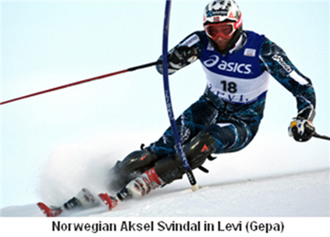
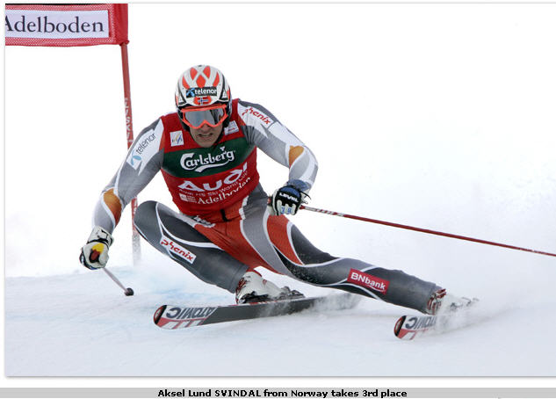

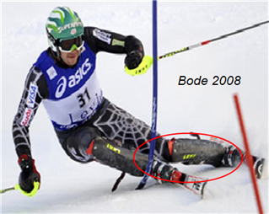
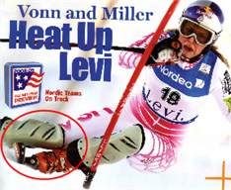
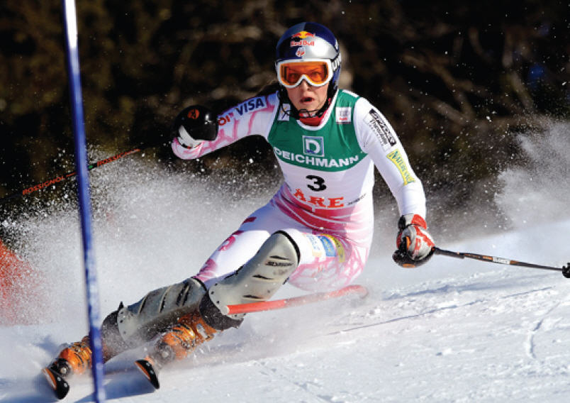

Skiing Principles

Timeless versus trends

The student lesson program is based on USSA principles that have been around for a long time.
When shaped skis were developed, it allowed much of the turn to be done in the top half of a turn rather than the second half. But many new theories about technique were introduced then which were not correct, and some instructors still teach these techniques. Instruction has a history of creating new techniques from a time when there were many different techniques. This tendency to produce trendy theories is still common in instruction, even though the basics of good technique have been around for a long time. The challenge is a solid execution of the basics, which takes time and precise feedback, because skiing is not intuitive and people can have a hard time feeling how they are actually moving.

Here are some of the theories that were incorrect: Ski more centered with less tip pressure, stay square with less inside lead, use equal pressure on both skis when racing, edge the new inside ski first, make only cross under turns with retraction and no crossover turns with extension, make only carved turns with no skidding, keep shins parallel throughout the turn (look close at the photos above to see there is so much inclination in some turns that a new type of “A” frame occurs in the top half of the turn; and it is created by the inclination rather extreme knee angulation in the second half of the turn which occurred in the original “A” frame.) Full rockered skis may require less tip pressure, but the body still needs to move forward relative to the feet.

Turning - Skis have an hour glass shape called sidecut (narrow in the waist.) If the ski is put on edge and pressured, it bends into an arc to make a turn. Skiers can also use rotary movements to pivot or steer the skis.

Forces - The forces in a turn can push skiers back and down. Progressively flexing the ankles and creating angulation keeps the skier’s momentum moving forward and downhill relative to the skis. The force increases with speed, steepness, and type of turn.

Think of the body separate from the skis. This is also referred to as the center of mass (COM) and the base of support. The COM can be in front of the skier. The body can be discussed in two parts, upper and lower, and they can work in opposite directions.

There are two types of forces in skiing, internal and external. The external forces are gravity and resistance from the snow and air. Internal forces are created by the body. Things move in a straight line unless some force changes their direction (inertia.) When the skis turn pressure increases as the body tries to go straight. Pressure is greater later in a turn when, gravity and centrifugal force begin to work in the same direction.

Pressure is needed to bend the skis, but there can be so much pressure that the skis will skid or chatter. To reduce the pressure, distribute it more evenly between the skis, use some down motion, or end the turn sooner.

Momentum moves a skier downhill when the edges are released. We can absorb any rebound and allow our skis to cross under our body, or extend toward the next turn and cross over our skis. The closer to the fall line the turn is ended, the greater the momentum is downhill over the skis.

Turn parts – A turn can be divided into at least two parts. The first half is from the crossover point to the apex, the furthest point of the turn. Then from the apex to the next crossover point is the second half. This describes a turn relative to the skis, but the skier starts moving in a straight path when the edges are released at the apex or later.

In the first part of the turn the skier’s body moves inside the new turn and starts edging the skis. The skis turn a skier until the edges are released. Then the skier start to move in a straight path while the skis continue turning until the next crossover point.

The longer edging movements are made past the fall line, the more the upper body moves across the hill and works against gravity. If the edges are released closer to the fall line, the skier’s inertia will move the skier downhill sooner for a quicker crossover.

Size and shape -Turns have a range of sizes from small to large. Speed is controlled by the shape of the turn, which means turning more across the hill; or the skis can be skidded. These are the two main characteristics of a turn; size and shape.

In small turns, skiers travel straight downhill while the skis turn beneath them. Small turns require quicker movements and more knee angulation. When making large turns, the skiers actually turns and follows the skis until they are released. Small turns can be made at slow and fast speeds, just like larger turns.

Four types of Movement

These four moves affect how we edge, turn, and pressure (fore/aft, ski to ski, overall,) our skis. Think of a body in two parts, an upper and lower half.

Fore/aft- moves maintain balance in the center of the skis, adjust pressure on the front and back of the skis, and can keep momentum moving forward relative to the skis. The ankles, knees, waist, and back play a major role. Most skiers will lack ankle flex, or flex their knees too; soon, quick, or long which reduces progressive forward movement and tip pressure for the next turn. Progressively moving forward and angulating, keeps the momentum moving toward the new turn.

Side to Side – moves are also called lateral movements and include weight transfer from foot to foot, inclination (the body moving inside to start the new turn,) and angulation which is tipping the upper body to the outside of the turn. Most skiers will naturally lean inside the turn and don’t add the angulation (this is called banking.)

Inclination and angulation control edging. Inclination occurs in the first part of a larger turns as inertia moves a skier inside the new turn. This passive movement can be supplemented with an extension of the new outside leg (long leg.)

Then angulation continues to increase edging and maintains lateral balance so you don’t fall inside the turn. Angulation can be created from the feet to the neck, but more knee angulation is used for small turns and hip angulation is used more in larger turns. Angulation should be progressive to the end of the turn to maintain the downhill momentum of the skier.

The rate of edging movements controls the size of a turn, quicker moves make smaller turns. How long edging movements are made determines how far across the hill a turn is made. Keep clear the difference between rate and duration, they are not the same.

Up and Down – moves are also called vertical movements; they adjust pressure and affect the lateral range of movement. Extending at the start of a turn begins to apply pressure which increase throughout the turn. Moving down can absorb the increasing pressure faster, slower, or at the same rate it is building.

In racing turns where most of the turn is in the top half of the turn, there is usually not much down motion. But when turns are completed later, the pressure can get very high and create a skid or push the skier back if it is not absorbed. Moving down also allows more knee angulation. When the edges are released the pressure can be absorbed, or skiers can extend through the transition.

Vertical moves can change the overall pressure on the skis. Moving down quickly reduces pressure at first and then increases it as the down motion stops. For every action there is an equal and opposite reaction, so if the down motion stops abruptly the energy rebounds and can un-weight the skis. Moving up quickly increases pressure at first, then decreases it near the top of the up motion which is another way to un-weight the skis.

Some skiers have a tall stance and not much vertical movement, but others have low stance and can move down too far. A low stance feels stable and allows more lateral motion for knee angulation, but it also is harder to resist the force of the turn.

The lower position results in a square stance, which means the upper and lower body are facing the same direction, so there is no inside lead (also called counter, parallel position, anticipation, strong inside half, upper lower body separation.) This makes it hard to angulate, so the skier will often brush the outside ski downhill to find the edge (called an abstem.) These skiers have a hard time making quick small turns because they can not quickly stop the down motion.

Rotary – moves produce an internal turning force to pivot or steer the skis. Pivoting is turning about the vertical axis of the body, such as hopping up and turning the skis. Steering is done by turning the feet over a longer period with weight on the skis, as when making a turn.

Rotary moves can be active or passive and they can occur in the upper or lower body. Skiers often rotate their upper body in the direction they want to turn, especially if they not moving forward and using their skis to turn. But turning the upper body first is how people move when they are walking, so it is very natural to rotate on skis. At the end of the rotation the turning force is transmitted to the skis. Rotation makes it hard to angulate.

In small turns the lower body turns under a stable upper body that is already facing downhill. It produces a wound up position with the lower body facing across the hill and the more massive upper body facing downhill. When the skis are un-weighted they automatically unwind or pivot to face downhill like the upper body. For every action there is an equal and opposite reaction so the upper body will start to rotate at a slower rate in the direction the skis were facing. A pole touch will block this rotation of the upper body.

PSIA

The Professional Ski Instructors of America (PSIA) is an organization that creates teaching methods, skiing techniques, and certifies instructors in these techniques. With PSIA certification an instructor can earn a bit more money and teach higher level lessons at some resorts.

If you decide to pursue PSIA certification understand that the student lessons at Mt. Holly and Pine Knob are based on principles from USSA, so be aware that they are different. Mt. Holly and Pine Knob instructors should focus on becoming very competent at teaching the student lesson program. If at some point you want to get PSIA certified various clinics will be available.

Keep clear the differences in the programs so you can pass your PSIA exam and teach the student lesson program properly, you will have to be good at both and not confuse them. PSIA has a strong focus on the steering, edging, and pressure movements of the new inside ski at the start of a turn. This is very different from our focus on using the new outside ski to turn with early weight transfer, ankle flex and angulation (tip and flex). This uses the ski and builds offensive movements right from the start. Steering is a secondary focus in the student lesson program.
Your Responsibility Code

The National Ski Area Association has developed this list of items for safe skiing. Every instructor should know this list.

- Always stay in control and be able to stop or avoid other people or objects.
- People ahead of you have the right of way. It is your responsibility to avoid them.
- You must not stop where you obstruct a trail or are not visible from above.
- Whenever starting downhill or merging into a trail, look uphill and yield to others.
- Always use devices to help prevent runaway equipment.
- Observe all posted signs and warnings. Keep off closed trails and out of closed areas.
- Prior to using any lift, you must have the knowledge and ability to load, ride, and unload safely.
Resources

1- US Ski Team training videos and CD’s- http://www.ussa.org/magnoliaPublic/ussa/en/formembers/coaches/learningmaterials/Alpine.html
USSA has a certification program for coaches-
http://www.ussa.org/magnoliaPublic/ussa/en/formembers/coaches/education.html

2 - Video analysis helps the instructor analyze and students understand, free v1- www.v1ski.com

3- World cup ski racing at universal sports - http://www.universalsports.com/skiing/index.html

4- Ski racing online- http://www.skiracing.com/,

5- FIS ski racing web site - http://www.fis-ski.com/uk/disciplines/alpineskiing/

6- PSIA http://www.psia.org/

